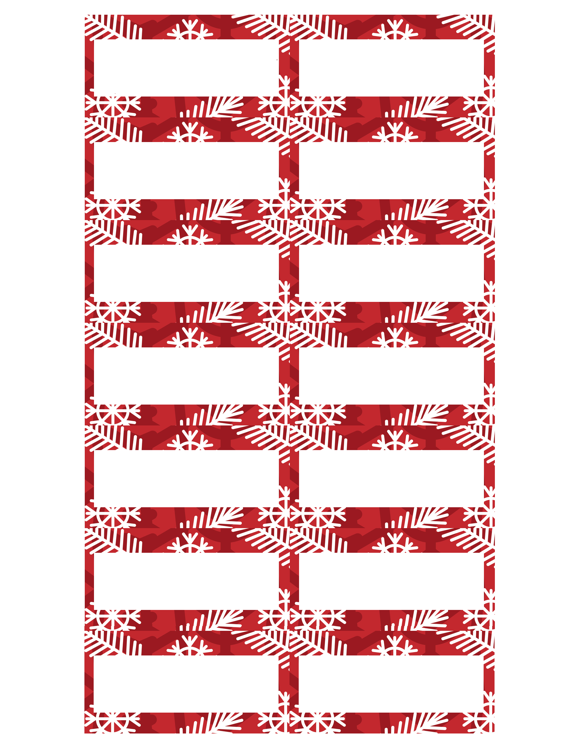

Click here to edit…

Click here to edit…

Click here to edit…

Click here to edit…

Click here to edit…

Click here to edit…

Click here to edit…

Click here to edit…

Click here to edit…

Click here to edit…

Click here to edit…

Click here to edit…

Click here to edit…

Click here to edit…

