custom printed

SILVERWARE BAGS

________________________________________________________________________

Created by Chica and Jo, crafters extraordinaire!
Learn more about us at www.ChicaAndJo.com
_____________________________________________________________

This document contains templates to create your own custom printed paper silverware bags, for use as place settings at weddings, parties, and events.

This template is sized to fit our 3” x 7.5” paper cutlery bags. For more
information about where to purchase our exclusive bags, and for complete assembly instructions with step-by-step photos, please visit our website at:
http://chicaandjo.com/diy-printed-silverware-bags

To create your own custom printed bags:

- Print the BASE page onto regular paper.
- Edit the text on the OVERLAY #1 page as desired.
- Put your BASE page back into the printer, making sure the edge with the feed arrows gets pulled into the rollers first.
- Print OVERLAY #1 onto the BASE page as a test.
    - If your design prints correctly on the bags, you have the right OVERLAY. If your design prints upside down, switch to OVERLAY #2 and repeat steps 2-4.
    - If the design isn’t centered in the bag outline, draw a new outline.
- Tape two bags to the BASE page where indicated by the outline.
- Print your OVERLAY onto the BASE, then carefully remove tape from bags.

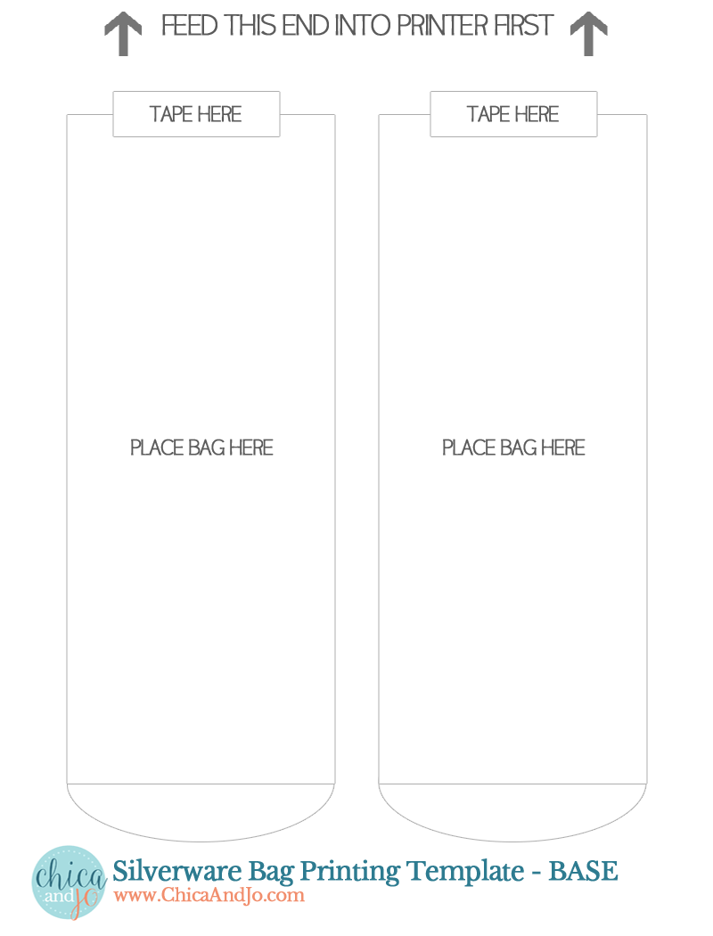
CLICK TO EDIT

KEEP TEXT
WITHIN THIS BOX
CLICK TO EDIT

KEEP TEXT
WITHIN THIS BOX
CLICK TO EDIT

KEEP TEXT
WITHIN THIS BOX
CLICK TO EDIT

KEEP TEXT
WITHIN THIS BOX

