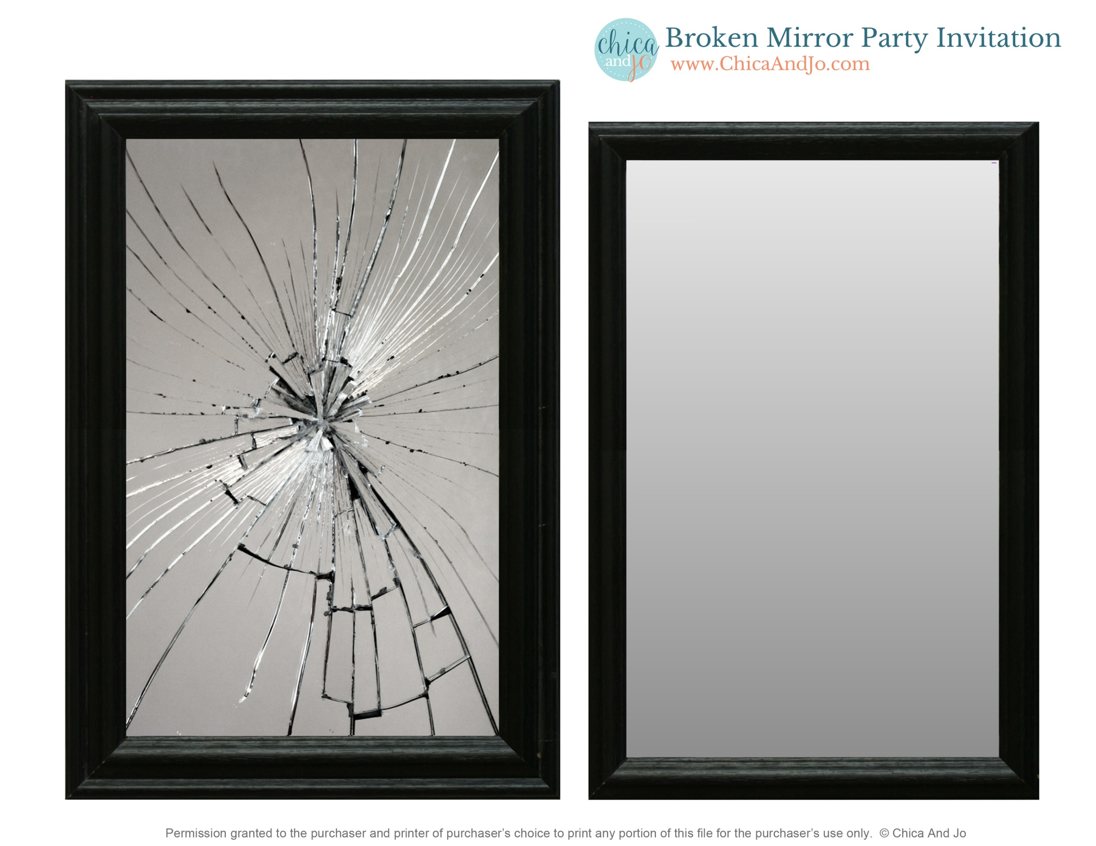

**FEELING**

**LUCKY?**

CAST YOUR SUPERSTITIONS ASIDE

AND COME CELEBRATE

CLICK TO EDIT

on FRIDAY THE 13th

Friday, August 13th

6:00 – 9:00 pm

IT’S 7 YEARS OF BAD LUCK IF YOU MISS THIS PARTY!

RSVP by August 6th

Dinner will be served. No gifts please.