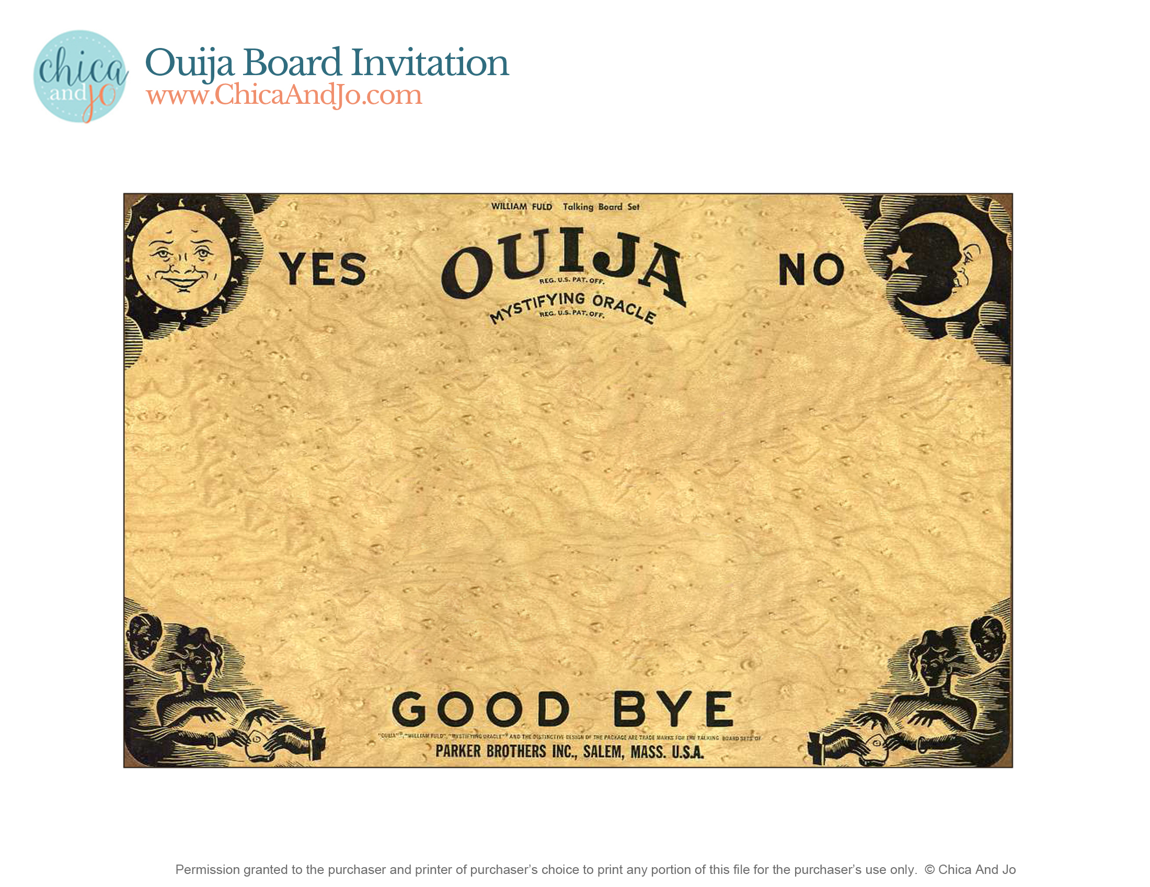

YOU’RE INVITED

TO: click here to edit

PLACE: click here to edit

RSVP: click here to edit

12.21.2019 8:00

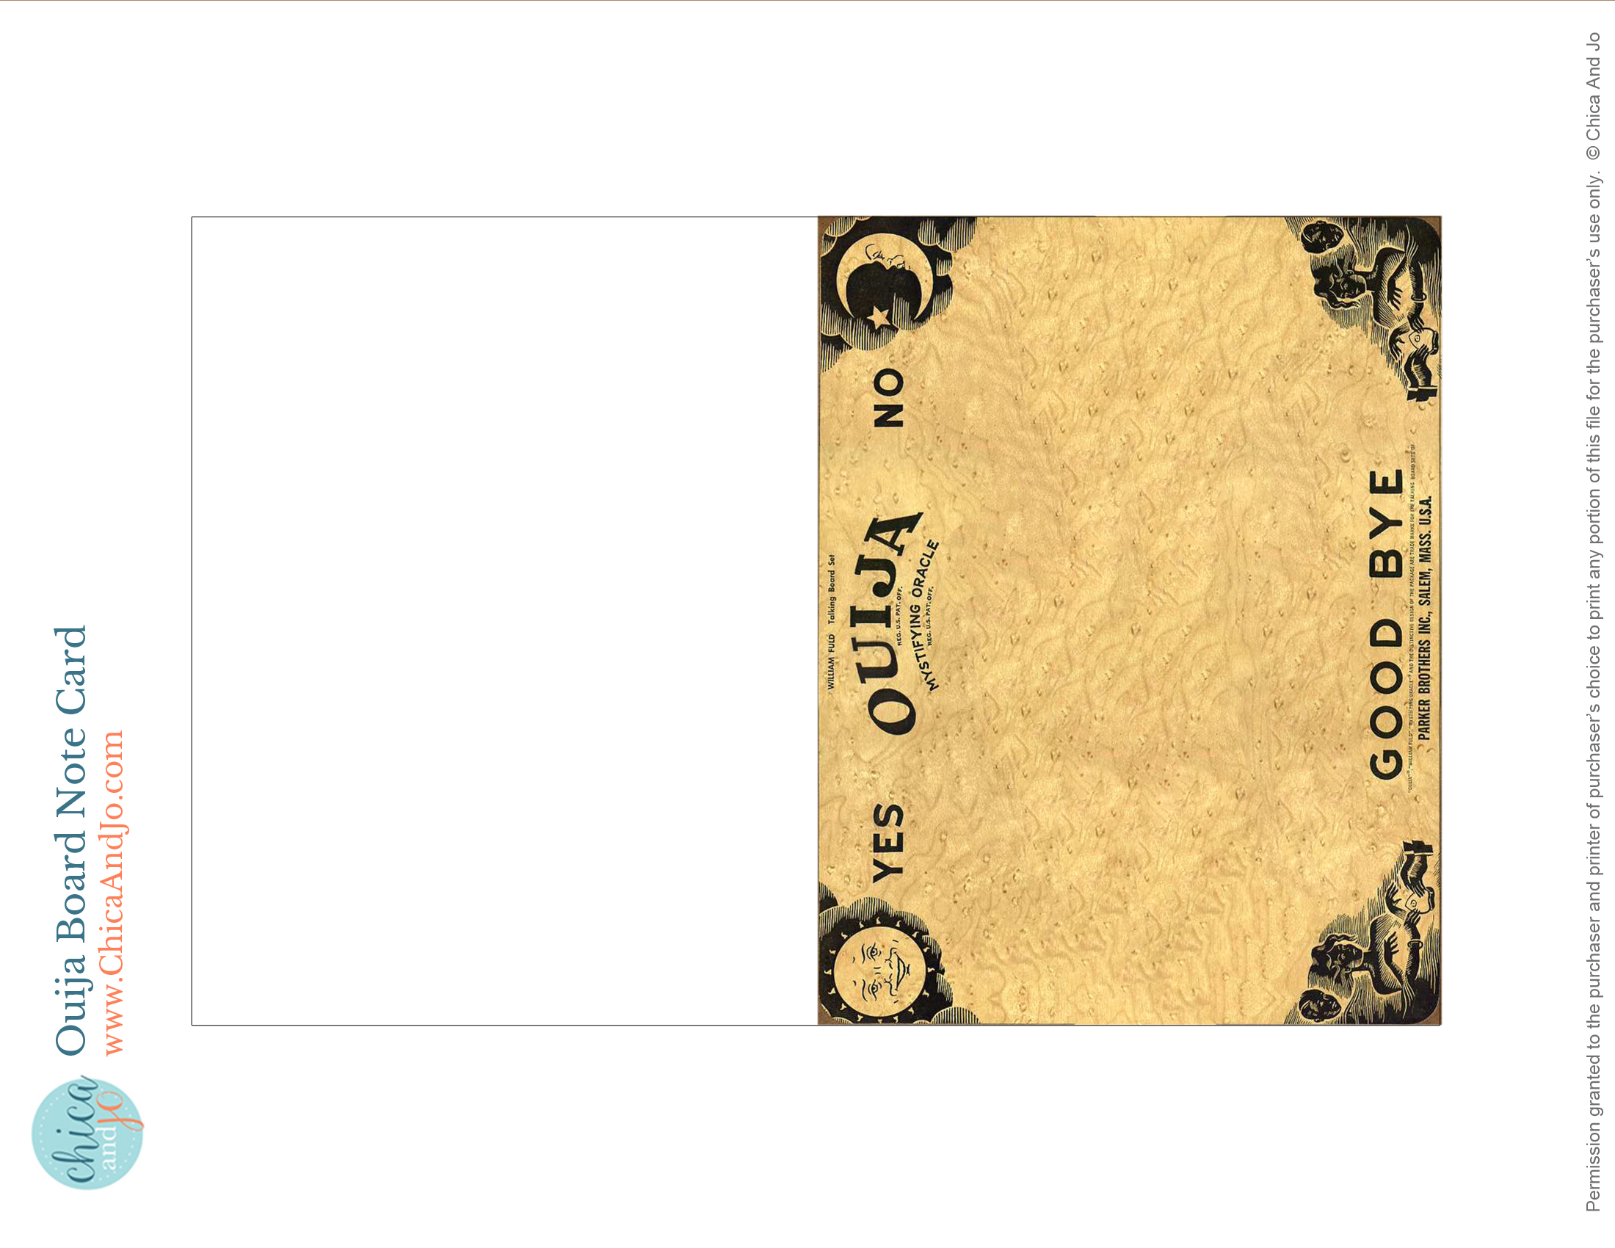

AS PREDICTED

YOU HELPED MAKE

IT A GREAT PARTY!